Lab: Consuming External Web Services

In this lab, you will consume an external web service that provides vehicle information for a given vehicle identification number.

Requirements

This lab requires that you use TrainingApp 8.0, ExternalApp 8.0, Guidewire Studio 8.0, and Chrome as your web browser. Start Guidewire Studio for Training App. Debug the Server.

To run ExternalApp, navigate to c:\Guidewire\ExternalApp and double-click the Start ExternalApp shortcut. The command window of ExternalApp will read "**** ContactManager ready ****" when the application is running.

To view, edit, and delete various contacts, log in to TrainingApp as Super User. The default URL for TrainingApp is <http://localhost:8880/ab/ContactManager.do>. The login/password for Super User is su/gw.

1. Connecting to a WSI web service

Acme needs to connect to a WSI web service hosted on an external system. The web service API offers a method to that take a VIN number as a string argument and the returns a string that contains the vehicle's color, year, make, and model.

Tasks

1. Create a new package called acmelab.ta.webservice
2. If needed, use the Navigation Bar to select the acmelab.ta folder.
3. Create a web service collection to access the VIN service
4. Create the appropriate name for the web service package.
5. Use recommended naming conventions for the web service collection.
6. ExternalApp's VehicleWsiAPI is accessible at: <http://localhost:9990/ab/ws/external/VehicleWsiAPI?WSDL>
7. Deploy your changes

Verification

ExternalApp must be running in order to verify your results. For each VIN numbers, verify the given result as listed in the following table:

|  |  |  |  |
| --- | --- | --- | --- |
| Vehicle Identification Number (VIN) |  |  | Result |
| 12345678901234567 |  |  | Blue 1991 Dodge Challenger |
| ABCDEFGHIJKLMNOPQ |  |  | Black 2007 BMW X3 |
| 111 |  |  | Vin is not 17 characters |
| $$$$$$$$$$$$$$$$ |  |  | Vin has invalid characters |

1. In Gosu Scratchpad, execute code that calls the web service
2. Run in the Debug process.
3. Connect to the web service using HTTP authentication with su/gw as the username/password.
4. Print the results to the console.
5. Verify the output
6. Verify the output in the Debug Console.

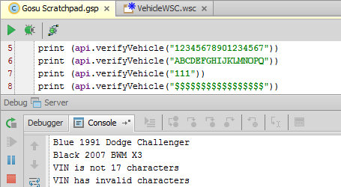

|  |  |
| --- | --- |
|  | Stop and ask your instructor to review your completed lab.  Create a new package VIN  A new Webservice collection vinrumneekwsc  Give url <http://localhost:9990/ab/ws/external/VehicleWsiAPI?WSDL>  Then in gosu scratch pad  var vehicleInfo= new acme.ta.webservice.vin.vinrumneekwsc.vehiclewsiapi.VehicleWsiAPI()  vehicleInfo.Config.Http.Authentication.Basic.Username = "su"  vehicleInfo.Config.Http.Authentication.Basic.Password = "gw"  var testVar= vehicleInfo.verifyVehicle("12345678901234567")  print(testVar)  print(vehicleInfo.verifyVehicle("ABCDEFGHIJKLMNOPQ"))  print(vehicleInfo.verifyVehicle(111))  print(vehicleInfo.verifyVehicle("$$$$$$$$$$$$$$$$")) |